Online Shopping system- web application
Login page – Black-Box, White-Box, Integration & System Testing (Tutorial 9)
Module Name: Login page (Black-Box, White-Box, Integration & System Testing)
Test case ID: TC009
Platform: Web application (https://www.saucedemo.com), Google Chrome on Windows
Login Method: username + password
Tester Name: VIDHI PATEL
Scenario ID: 1
Scenario: Black-Box : login with valid credentials
Test steps:
- Enter valid username : standard_user
- Enter valid password : secret_sauce
- Click on login
Expected: Successfully logged in and Products page opens
Actual: Successfully logged in and Products page opened
Status: Pass

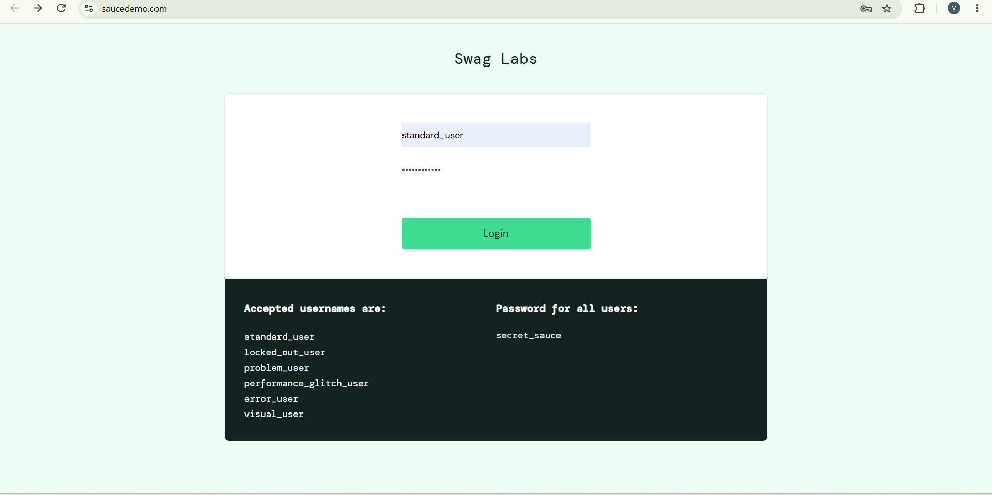
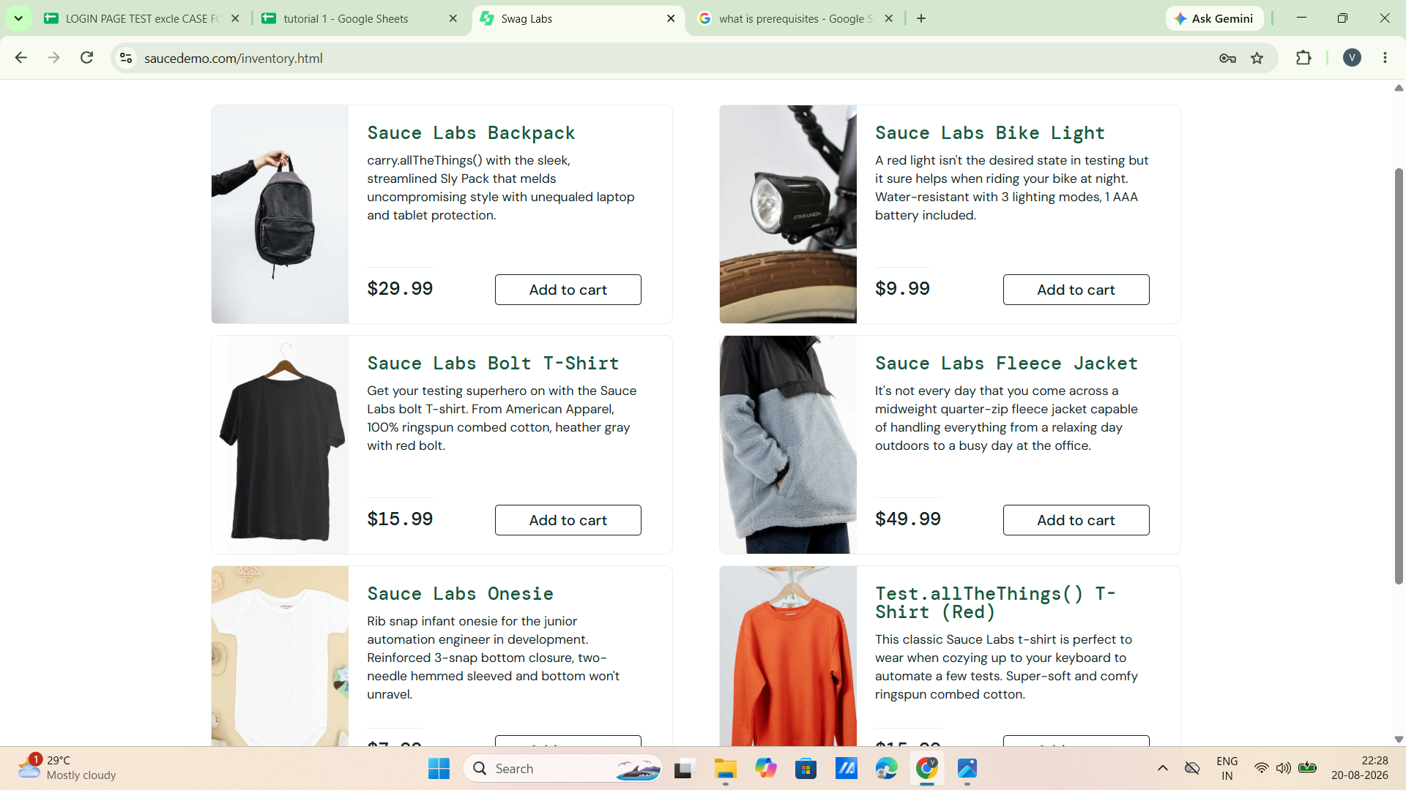

Scenario ID: 2
Scenario: Black-Box : login with invalid password
Test steps:
- Enter valid username : standard_user
- Enter invalid password : Godisgreat
- Click on login
Expected: Epic sadface: Username and password do not match any user in this service
Actual: Error displayed: Epic sadface: Username and password do not match any user in this service
Status: Pass

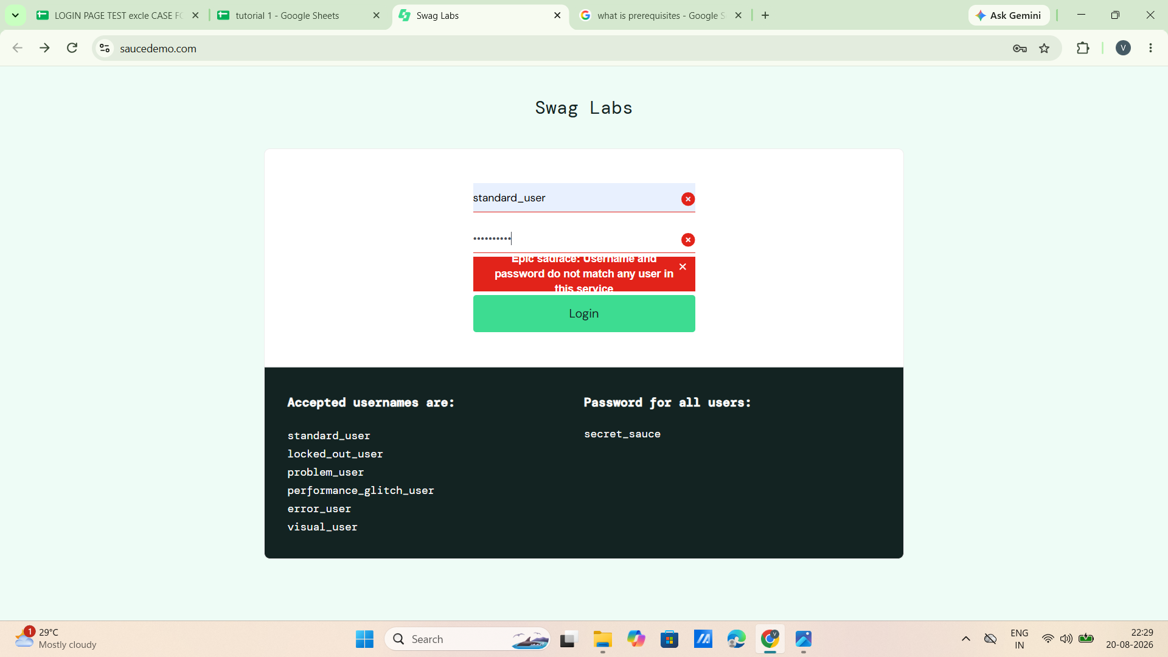

Scenario ID: 3
Scenario: Black-Box : login with invalid username
Test steps:
- Enter invalid username : vidhi patel
- Enter valid password : secret_sauce
- Click on login
Expected: Epic sadface: Username and password do not match any user in this service
Actual: Error displayed: Epic sadface: Username and password do not match any user in this service
Status: Pass

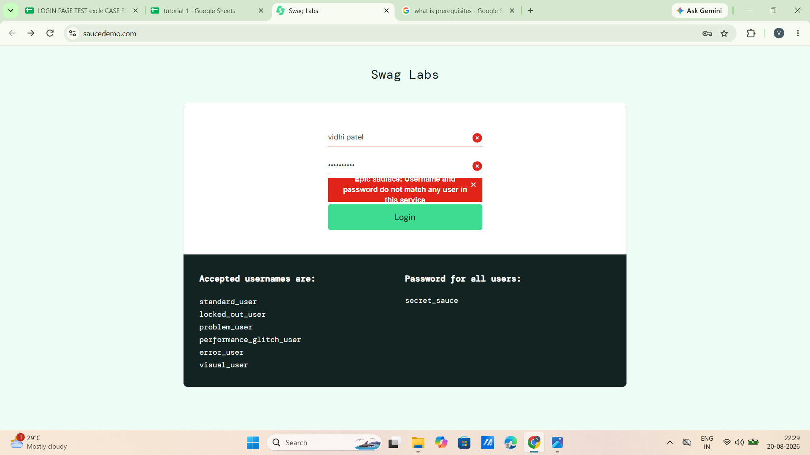

Scenario ID: 4
Scenario: Black-Box : login with empty username
Test steps:
- Leave blank at username : -
- Enter valid password : secret_sauce
- Click on login
Expected: Epic sadface: Username is required
Actual: Error displayed: Epic sadface: Username is required
Status: Pass

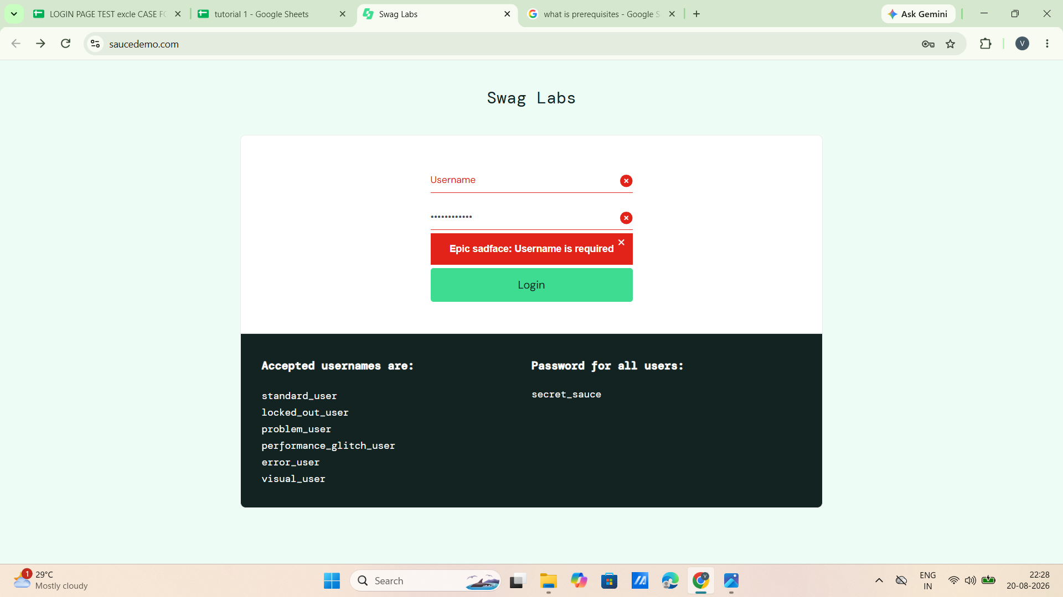

Scenario ID: 5
Scenario: Black-Box : login with empty password
Test steps:
- Enter valid username : standard_user
- Leave blank at password : -
- Click on login
Expected: Epic sadface: Password is required
Actual: Error displayed: Epic sadface: Password is required
Status: Pass

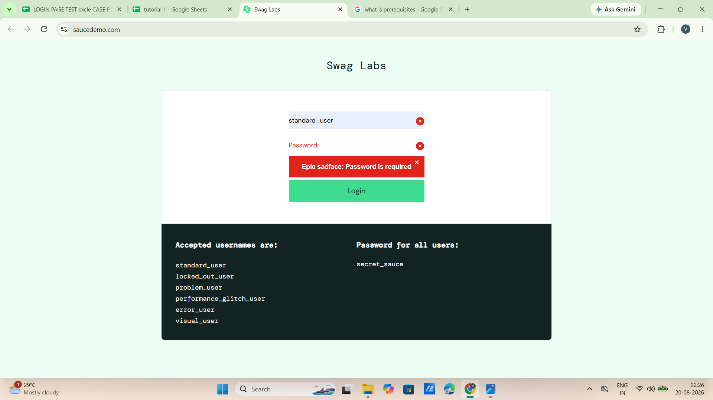

Scenario ID: 6
Scenario: White-Box : verify if-condition (valid credentials branch)
Test steps:
- Enter valid username : standard_user
- Enter valid password : secret_sauce
- Click on login
- Check that the TRUE branch (successful login) executes
Test input: Condition TRUE : username and password match a registered user
Expected: If-branch executed : user is redirected to Products page (inventory.html)
Actual: If-branch executed : Products page opened
Status: Pass

Scenario ID: 7
Scenario: White-Box : verify else-condition (invalid credentials branch)
Test steps:
- Enter invalid username : vidhi patel
- Enter invalid password : Godisgreat
- Click on login
- Check that the FALSE branch (error message) executes
Test input: Condition FALSE : username and password do not match any user
Expected: Else-branch executed : Epic sadface: Username and password do not match any user in this service
Actual: Else-branch executed : error message displayed
Status: Pass

Scenario ID: 8
Scenario: Integration : Login module -> Products (Inventory) module
Test steps:
- Enter valid username : standard_user
- Enter valid password : secret_sauce
- Click on login
- Check that the Products page opens with the product list
Expected: Products page opens after login (communication between Login and Products modules)
Actual: Products page opened with product list
Status: Pass

Scenario ID: 9
Scenario: System : complete flow: login -> products -> add to cart -> cart
Test steps:
- Login with standard_user / secret_sauce
- Check that the Products page is displayed
- Click on Add to cart for Sauce Labs Backpack
- Click on the cart icon and check the cart
Expected: Cart page shows Sauce Labs Backpack, qty 1, price $29.99
Actual: Cart page showed Sauce Labs Backpack, qty 1, price $29.99
Status: Pass

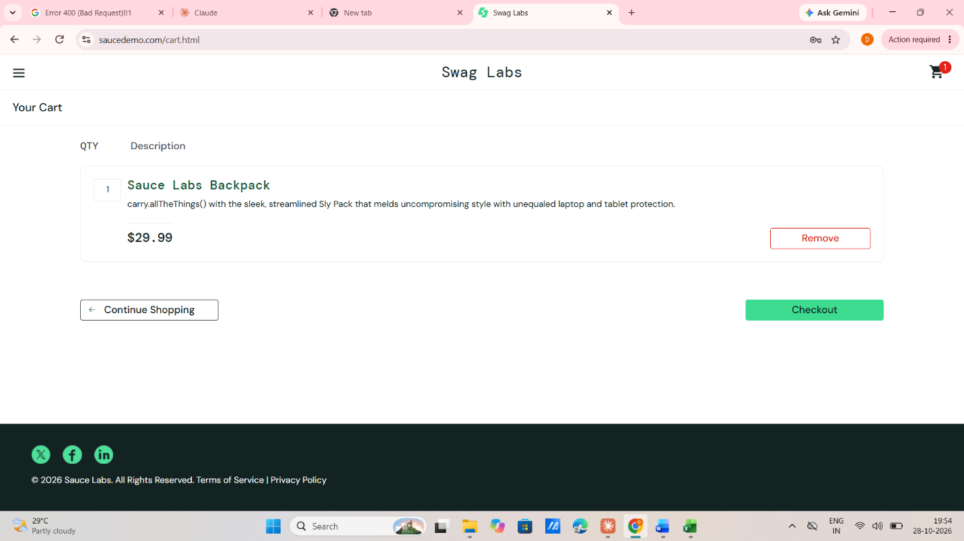

Test Summary
Total Test Cases Designed | 9
Total Test Cases Executed | 9
Total Passed Test Cases | 9
Total Failed Test Cases | 0
Pass Percentage (%) | 100%
Overall Test Status | Pass
Execution Date | 28/10/2026

